Organ Donate



A project report submitted to

Rajiv Gandhi Proudyogiki Vishwavidhyalaya, Bhopal

towards partial fulfillment of

the degree of

**MASTER OF COMPUTER APPLICATION**

**{2020-21}**

**Submitted by:**

Mohit Rathore

0801CA191016

**Guided By:**

Mr Upendra Singh

*Department of Information*

*Technology*

Department of Information Technology

**SHRI G.S. INSTITUTE OF TECHNOLOGY AND SCIENCE**

**INDORE (M.P.)**

**SHRI G.S. INSTITUTE OF TECHNOLOGY AND SCIENCE**

**INDORE (M.P.)**



**Recommendation**

The project report entitled **“Organ Donate”** submitted by **Mohit Rathore** students of Second year in the session 2020-21, towards partial fulfillment of the degree of **Master of Computer Applications** of Rajiv Gandhi Proudyogiki Vishwavidhyalaya, Bhopal, is a satisfactory account of his work and is recommended for the award of degree**.**

**Upendra Singh**

Project Guide

Department of IT

**Head**

Department of IT

**Dean(Academics)**

**S.G.S.I.T.S.,Indore**

**SHRI G.S. INSTITUTE OF TECHNOLOGY AND SCIENCE**

**INDORE (M.P.)**



**Certificate**

The project report entitled **“*Organ Donate*”** submitted by **Mohit Rathore** students of Second year in the session 2020-21, towards partial fulfillment of the degree of **Master of Computer Applications** of Rajiv Gandhi Proudyogiki Vishwavidhyalaya, Bhopal, is a satisfactory account of their work and is approved for award of the degree.

**Internal Examiner External Examiner**

**Date**

**Acknowledgement**

I am heartily pleased to acknowledge all those people who have helped me in the successful completion of this project. With great pleasure i express my heartfelt gratitude to our esteemed guide, **Mr. Upendra Singh** Lecturer Department of information Technology, S.G.S.I.T.S. Indore. His persistent encouragement, perpetual motivation, everlasting patience and valuable technical inputs in discussions have enabled the successful completion of this project. His invaluable help, advice and constant encouragement helped us a lot and provide impetus to the progress of the project. We extend our profound indebtedness to the Head of the department **Ms. Sunita Varma,** the word loose their worth for her invaluable guidance, continuous encouragement and cooperation in every respect.

I sincerely wish to express our gratitude to all the members of staff of M.C.A.who have extended their cooperation at all times and have contributed in their own way in developing the project. Successful completion of a project is not an individual effort. It is an outcome of the cumulative effort of a number of persons, each having his own importance to the objective. We are thankful to our parents for being a constant source of encouragement in all our endeavors. Indeed it is their support that helps us through the ups and downs of life. The support and suggestion of our friends are worth appreciation and thankfulness. *A blend of gratitude, pleasure, great satisfaction and indebtedness is what, we feel to convey to all those who have directly or indirectly contributed to the successful completion of our project work.*

**Mohit Rathore**

***Table of Contents***

**Chapter 1.**

**Introduction**

1.1 Objective …1

1.2. Scope …1

1.3. Technologies used …1

**Chapter 2.**

**Analysis 2-5**

2.1. Data Flow Diagram

2.2. Class Diagram

2.3. Component Diagram

2.4. Use Case Diagrams

**Coding 6-17**

**Output 18**

**References**

**Chapter 1**

**Introduction**

* 1. **Objective**

Aim of “**Organ Donating System**” to raise awareness that individuals can save lives and improve the health of others by **Donating the organ and blood.**

* 1. **Scope**

Project is to simplify and automate the process of searching for **organ and blood .**

* 1. **Technologies Used**

1. Java

**Chapter 2**

**Analysis**

**UseCase Diagram**

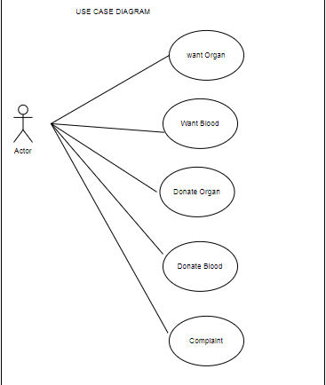

**Class Diagram**

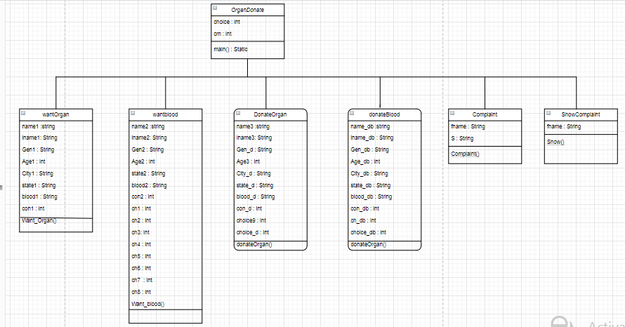

**DFD Diagram**

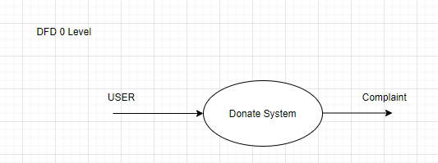

**Component Diagram**

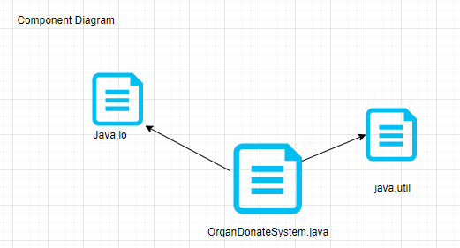

**State Diagram**

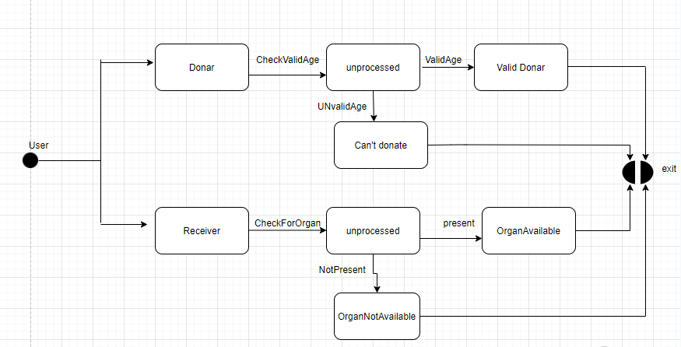

**Sequence Digram**

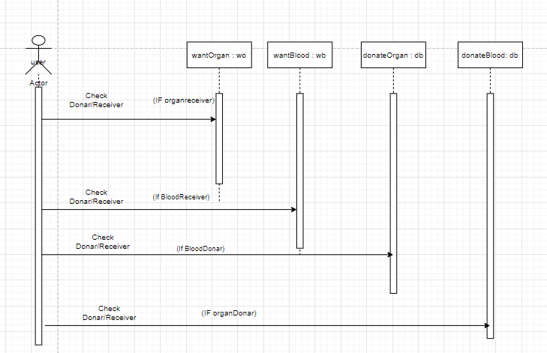

**Coding**

package com.company;

import java.io.FileInputStream;

import java.io.FileOutputStream;

import java.util.Scanner;

public class OrganDonate {

static Scanner sc = new Scanner(System.in);

static {

System.out.println("************care************");//donor

System.out.println("THE ORGAN DONATING/FINDING SITE");//organ

System.out.println("%%%%%%%%%%-WELCOME-%%%%%%%%%%");

}

public static <showComplaint> void main(String[] args) {

//object of classes.

wantOrgan wo = new wantOrgan();

wantBlood wb = new wantBlood();

donateBlood db = new donateBlood();

donateOrgan dor = new donateOrgan();

System.out.println("Select the choice you want");

System.out.println("1:-you want an organ to replace");

System.out.println("2:-you want urgent blood");

System.out.println("3:-You want to Donate an Organ");

System.out.println("4:-you wanna be blood donor");

int choice = sc.nextInt();

switch (choice) {

case 1:

wo.Want_organ();

break;

case 2:

wb.Want_blood();

break;

case 3:

dor.Donate_oragan();

break;

case 4:

db.Donate_blood();

break;

default:

System.out.println("Not an valid choice");

System.exit(1);

}

Complaint feed = new Complaint();

System.out.println("We would like to hear your feedback with us...\n" +

"Press 1 to for complaint \n" +

"Press 2 to exit without any complaint \n");

int fb = sc.nextInt();

if (fb == 1) {

feed.complaint();

} else if (fb == 2)

System.exit(0);

else System.out.println("wrong input. Exiting!");

ShowComplaint showComplaint = new ShowComplaint();

showComplaint.show();

}

static class wantOrgan {

Scanner sc = new Scanner(System.in);

void Want_organ() {

System.out.println("please enter organ you want");

String organ = sc.next();

System.out.println("please give us some details");

System.out.println("Enter patient's first name");

String name1 = sc.next();

System.out.println("Enter patient's last name");

String lname1 = sc.next();

System.out.println("Gender:-Male/Female");

String Gen1 = sc.next();

System.out.println("Enter patient's age");

int age1 = sc.nextInt();

System.out.println("Enter city");

String city1 = sc.next();

System.out.println("Enter state");

String state1 = sc.next();

System.out.println("Enter your blood grup");

String blood1 = sc.next();

System.out.println("Enter you contact details");

int con1 = sc.nextInt();

System.out.println("We will contact you if we found some good news for you");

System.out.println("Till then please be safe and take care of patient");

}

}

static class wantBlood {

void Want_blood() {

System.out.println("please enter blood group you want");

String blood2 = sc.next();

System.out.println("please give us some details of patient");

System.out.println("Enter patient's name ");

String name2 = sc.next();

System.out.println("Enter patient's last name ");

String lname2 = sc.next();

System.out.println("Enter patient's age ");

int age2 = sc.nextInt();

System.out.println("Gender:-Male/Female");

String Gen_wb = sc.next();

System.out.println("Enter City Name: ");

String city2 = sc.next();

System.out.println("Enter Near By hospital's Name\"");

String hospi1 = sc.next();

System.out.println("Enter contact no-");

int con2 = sc.nextInt();

System.out.println("You can also change blood in blood bank by giving eqaul amount of another type of blood");

System.out.println("press 1 for Blood Excange in Blood Bank");

System.out.println("press 2 for print and check details given by you");

System.out.println("press 3 for exit");

int ch2 = sc.nextInt();

switch (ch2)//choice for blood exchange and details

{

case 1:

System.out.println("Enter choice ");

System.out.println("Press 1:-Indore");

System.out.println("Press 2:-Ujjain");

System.out.println("Press 3:-Bhopal");

System.out.println("Press 4:-Ratlam");

System.out.println("Press 5:-Gwalior");

int ch3 = sc.nextInt();//17

switch (ch3)//choice of city for hospital

{

case 1:

System.out.println("Here are some Details of hospitals in Indore,in which you can Exchange blood");

System.out.println("1:-Arihant Hospital and Research Center");

System.out.println("2:-Shalby hospital");

System.out.println("3:-Apollo hospital");

System.out.println("Press the no among the hospital for more details");

int ch4 = sc.nextInt();//var for selecting hospitals in selected indore

switch (ch4) {

case 1:

System.out.println("Arihant hospital and Reseach center");

System.out.println("Address:- 283-a,Gumasta Nagar,Scheme-71,Indore");

System.out.println("Patient's Feedback Star-****/*****");

System.out.println("contact no:-0731-111111");

break;

case 2:

System.out.println("Shalby Hospital");

System.out.println("Address:- 5,6 R S Bhandari Marg,Indore");

System.out.println("Patient's Feedback Star-***/*****");

System.out.println("contact no:-0731-000000");

break;

case 3:

System.out.println("Apollo Hospital");

System.out.println("Adress:-74-c,Vijay nagar,Indore");

System.out.println("Patient's Feedback Star-****/*****");

System.out.println("contact no:-0731-123456");

break;

default:

System.out.println("Invalid choice");

System.exit(1);

}

break;

case 2:

System.out.println("Here are some Details of Hospitals in Ujjain,in which you can Exchange blood");

System.out.println("1:-R D Gardi Hospital ");

System.out.println("2:-Tejankar Hospital and Research center");

System.out.println("3:-Deshmukh hospital");

System.out.println("Press the no among the Hospital for more details");

int ch5 = sc.nextInt();//var for selecting hospitals in selected ujjain

switch (ch5) {

case 1:

System.out.println("Ruxmaniben Deepchand Gardi Hospital");

System.out.println("Address:- Agar road, Ujjain");

System.out.println("Patient's Feedback Star-****/*****");

System.out.println("contact no:-0734-111111");

break;

case 2:

System.out.println("Tejankar Hospital and Research center");

System.out.println("Address:- 4,near Vishal Mega mart,Ujjain");

System.out.println("Patient's Feedback Star-*****/*****");

System.out.println("contact no:-0734-000000");

break;

case 3:

System.out.println("Deshmukh hospital");

System.out.println("Adress:-43,Sanwer Road,Nana Kheda,Ujjain");

System.out.println("Patient's Feedback Star-****/*****");

System.out.println("contact no:-0734-444444");

break;

default:

System.out.println("Invalid choice");

System.exit(1);

}

break;

case 3:

System.out.println("Here are some Details of Hospitals in Bhopal,in which you can Exchange blood");

System.out.println("1:-Bansal Hospital");

System.out.println("2:-Janki Hospital");

System.out.println("3:-Galaxy hospital");

System.out.println("Press the no among the Hospital for more details");

int ch6 = sc.nextInt();//var for selecting hospitals in selected Bhopal

switch (ch6) {

case 1:

System.out.println("Bansal Hospital");

System.out.println("Address:- Chuna Bhatti Road, Bhopal");

System.out.println("Patient's Feedback Star-****/*****");

System.out.println("contact no:-0755-4086000");

break;

case 2:

System.out.println("Janki Hospital");

System.out.println("Address:- Gulmohar Colony,Bhopal");

System.out.println("Patient's Feedback Star-*****/*****");

System.out.println("contact no:-0755-7854637");

break;

case 3:

System.out.println("Galaxy Hospital");

System.out.println("Adress:-25,Danish Kunj,Bhopal");

System.out.println("Patient's Feedback Star-****/*****");

System.out.println("contact no:-0755-3545366");

break;

default:

System.out.println("Invalid choice");

System.exit(1);

}

break;

case 4:

System.out.println("Here are some Details of Hospitals in Ratlam,in which you can Exchange blood");

System.out.println("1:-Samarpan Hospital");

System.out.println("2:-Maa Gayatri Hospital");

System.out.println("3:-Janak hospital");

System.out.println("Press the no among the Hospital for more details");

int ch7 = sc.nextInt();//var for selecting hospitals in selected Ratlam

switch (ch7) {

case 1:

System.out.println("Samarpan Hospital");

System.out.println("Address:- Opp. Ajanta Hotel,Ratlam");

System.out.println("Patient's Feedback Star-*****/*****");

System.out.println("contact no:-09302112234");

break;

case 2:

System.out.println("Janki Hospital");

System.out.println("Address:- 80 Feet Road,Ratlam");

System.out.println("Patient's Feedback Star-****/*****");

System.out.println("contact no:-07412264040");

break;

case 3:

System.out.println("Janak Hospital");

System.out.println("Adress:-Shastri Nagar,Ratlam");

System.out.println("Patient's Feedback Star-****/*****");

System.out.println("contact no:-9000661115");

break;

default:

System.out.println("Invalid choice");

System.exit(1);

}

break;

case 5:

System.out.println("Here are some Details of Hospitals in Gwalior,in which you can Exchange blood");

System.out.println("1:-Apollo Spectra Hospital");

System.out.println("2:-Prime Hospital");

System.out.println("3:-Kalyan hospital");

System.out.println("Press the no among the Hospital for more details");

int ch8 = sc.nextInt();//var for selecting hospitals in selected gwalour

switch (ch8) {

case 1:

System.out.println("Apollo Spectra Hospital");

System.out.println("Address:- Vikas Nagar ,Gwalior");

System.out.println("Patient's Feedback Star-*****/*****");

System.out.println("contact no:-8448440991");

break;

case 2:

System.out.println("Prime Hospital");

System.out.println("Address:- City Center,Gwalior");

System.out.println("Patient's Feedback Star-****/*****");

System.out.println("contact no:-7514048499");

break;

case 3:

System.out.println("Kalyan Hospital");

System.out.println("Adress:-Laxmi Bai Colony,Gwalior");

System.out.println("Patient's Feedback Star-*****/*****");

System.out.println("contact no:-07514087244");

break;

default:

System.out.println("Invalid choice");

System.exit(1);

}

break;

default:

System.out.println("Invalid Choice or We Dont Have Details of Other City at this time");

System.out.println("SOORY FOR INCONVINANCE");

System.exit(1);

}

case 2:

System.out.println("The given details are ");

System.out.println("blood group you want" + blood2);

System.out.println("Patient's name:-" + name2 + " " + lname2);

System.out.println("Patient's Age:-" + age2);

System.out.println("Gender:-" + Gen_wb);

System.out.println("City:-" + city2);

System.out.println("Hospital:-" + hospi1);

System.out.println("Contact Number:-" + con2);

System.out.println("We will contact you if we found some good news for you");

System.out.println("Till then please be safe and take care of patient");

break;

case 3:

System.exit(1);

break;

default:

System.exit(1);

break;

}

}

//System.exit(1);

}

static class donateOrgan {

donateBlood db = new donateBlood();

void Donate_oragan() {

System.out.println("You'r Doing Great Thing");

System.out.println("Please Give Us Few Details");

System.out.println("Enter Donor's First Name ");

String Firstn3 = sc.next();

System.out.println("Enter Donor's Last Name");

String lastn3 = sc.next();

System.out.println("Gender:-Male/female");

String Gen_d = sc.next();

System.out.println("Enter Donor's Age");

int Age3 = sc.nextInt();

if (Age3 <= 50) {

System.out.println("We Encourage Your Courage");

System.out.println("But your Age Is not Accetable for donating Organ ");

System.out.println("Perhaps You can also Donate blood ");

System.out.println("Press 1 For Go to donate blood ");

int Choice9 = sc.nextInt();

if (Choice9 == 1) {

db.Donate_blood();

} else {

System.out.println("Thankyou for Visiting us");

System.exit(1);

}

}

int Choice_d = sc.nextInt();

if (Choice_d == 1) {

System.out.println("Sorry the Donor Cannot Donate Oragan For self And Other's Health Issue");

System.exit(1);

} else {

System.out.println("Enter Organ");

String Organ_d = sc.next();

System.out.println("Enter Blood Group");

String Blood_d = sc.next();

System.out.println("Enter City");

String City_d = sc.next();

System.out.println("Enter State");

String State_d = sc.next();

System.out.println("Enter Your Contact no");

int Con_d = sc.nextInt();

System.out.println("If We Found Anything Related To you ,We Will contact You");

System.out.println("Till Then,please Be Safe....................");

System.out.println("*******************Thank-you******************************");

}

}

}

static class donateBlood {

void Donate_blood() {

System.out.println("Thank-you for Saving Some Precious Life");

System.out.println("Please Give Us Some details Of Donor");

System.out.println("Enter Donor's Name");

String Name_db = sc.next();

System.out.println("Enter Donor's Last name");

String Lname_db = sc.next();

System.out.println("Gender:-Male/Female");

String Gen_db = sc.next();

System.out.println("Donor's Age");

int Age_db = sc.nextInt();

if (Age_db <= 60) {

System.out.println("We Encourage Your Courage");

System.out.println("But your Age Is not Accetable for donating Blood ");

} else {

System.out.println("Is Donor having Any Serious Diseases");

System.out.println("Like Cancer,Daibities etc");

System.out.println("Press 1, IF he/she is Suffering from them");

int Ch_db = sc.nextInt();

if (Ch_db == 1) {

System.out.println("Sorry the Donor Cannot Donate Oragan For self And Other's Health Issue");

System.exit(1);

} else {

System.out.println("Enter Blood Group");

String Blood_db = sc.next();

System.out.println("Enter City");

String City_db = sc.next();

System.out.println("Enter State");

String State_db = sc.next();

System.out.println("Enter Your Contact no");

int Con_db = sc.nextInt();

System.out.println("If We Found Anything Related To you ,We Will contact You");

System.out.println("Till Then,please Be Safe.......................");

System.out.println("********************Thank-you*******************");

}

}

}

}

static class Complaint {

void complaint() {

Scanner sc = new Scanner(System.in);

System.out.println("Enter your name");

String fname = sc.nextLine();

try {

FileOutputStream fout = new FileOutputStream(fname + ".txt");

System.out.println("Please write your complaint is about how a hospital has treated you................");

String s = sc.nextLine();

byte b[] = s.getBytes();//converting string into byte array

fout.write(b);

fout.close();

System.out.println("Thank you for your visit. \n");

} catch (Exception e) {

System.out.println(e);

}

}

}

static class ShowComplaint

{

void show()

{

Scanner sc = new Scanner(System.in);

System.out.println("Enter your name to open complaint");

String fname = sc.nextLine();

try {

FileInputStream fin = new FileInputStream(fname + ".txt");

int i = 0;

while ((i = fin.read()) != -1) {

System.out.print((char) i);

}

fin.close();

} catch (Exception e) {

System.out.println("File not found");

}

}

}

}

**Result**

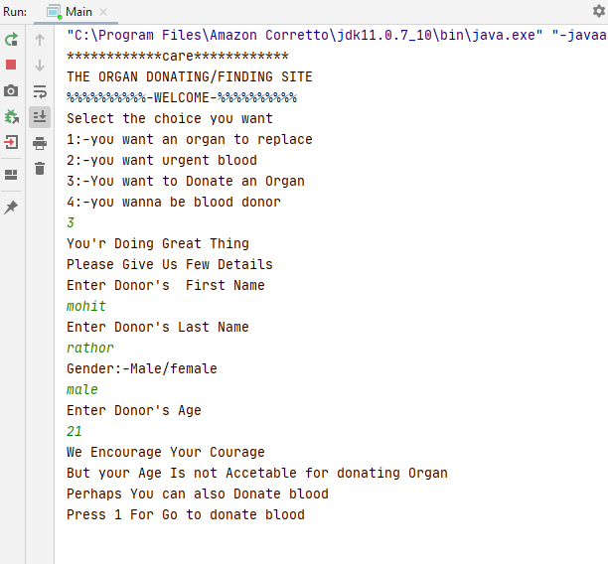

**References**

* [www.google.com](http://www.google.com)
* [www.javatpoint.com](http://www.javatpoint.com)
* [www.geeksforgeeks.com](http://www.geeksforgeeks.com)
* [www.stackoverflow.com](http://www.stackoverflow.com)